**Batch: A3 Roll No.: 16010122074**

**Experiment / assignment / tutorial No. 02**

**Grade: AA / AB / BB / BC / CC / CD /DD**

**Signature of the Staff In-charge with date**

EESHANYA JOSHI

|  |
| --- |
| **TITLE : Control Statement** |

**AIM:** Create a class myMath. The class contains the following static methods.

i) power (x, y) – to compute x y

ii) fact (x) – to compute x!

Write a program to find the following series.

* ex = 1 +(x/1!)+ (x2/2!) + (x3/3!) + (x4/4!) + … upto n terms (n given by user).
* (1+x)n = 1 +(nx/1!)+ ((n(n-1)x2)/2!) ........ upto n terms (n given by user).

**(Do not make use of inbuilt functions. Use the functions of user defined class MyMath.)**

**_____________________________________________________________________**

**Expected OUTCOME of Experiment:**

**CO2:** Explore arrays, vectors, classes and objects in C++ and Java.

**______________________________________________________________________**

**Books/ Journals/ Websites referred:**

1. E. Balagurusamy , “Programming with Java” McGraw-Hill.
2. Sachin Malhotra, Saurabh Choudhary, “Programming in Java”, Oxford Publications.

**_____________________________________________________________________**

**Pre Lab/ Prior Concepts**

Java basic constructs (like if else statement, control structures, and data types

Programming languages provide various control structures that allow for more complicated execution paths.

A loop statement allows us to execute a statement or group of statements multiple times and following is the general form of a loop statement in most of the programming languages −

|  |  |
| --- | --- |
| **Sr.No.** | **Loop & Description** |
| 1 | [**while loop**](https://www.tutorialspoint.com/java/java_while_loop.htm)  Repeats a statement or group of statements while a given condition is true. It tests the condition before executing the loop body. |
| 2 | [**for loop**](https://www.tutorialspoint.com/java/java_for_loop.htm)  Execute a sequence of statements multiple times and abbreviates the code that manages the loop variable. |
| 3 | [**do...while loop**](https://www.tutorialspoint.com/java/java_do_while_loop.htm)  Like a while statement, except that it tests the condition at the end of the loop body. |

**Loop Control Statements**

Loop control statements change execution from its normal sequence. When execution leaves a scope, all automatic objects that were created in that scope are destroyed.

Java supports the following control statements. Click the following links to check their details.

|  |  |
| --- | --- |
| **Sr.No.** | **Control Statement & Description** |
| 1 | [**break statement**](https://www.tutorialspoint.com/java/java_break_statement.htm)  Terminates the loop or switch statement and transfers execution to the statement immediately following the loop or switch. |
| 2 | [**continue statement**](https://www.tutorialspoint.com/java/java_continue_statement.htm)  Causes the loop to skip the remainder of its body and immediately retest its condition prior to reiterating. |

**Class Diagram:**

|  |
| --- |
| **Exp 3** |
| -num : Int  -arr[][] : Int  -i : Int  -runs_sum:int  -runs_avg : float  -sum : float  -matches: Int  -j: int  Scanner sc |
| +main() |

**Algorithm:**

**Import Scanner.**

**Define a class exp2.**

Take input for number of terms and x.

Create Switch Case

Case 1: to print series 1

Print.

Case 2:to print series 2

Print.

Close the switch case

**Define a class s1**

Create a for loop to calculate the sum of series

**Define a class s2**

Create a for loop to calculate the sum of series

**Define a class Power**

Calculate the power using for loop and not using inbuilt method

**Define a class Fact**

Calculate the fact using for loop and not using inbuilt method

**Implementation details:**

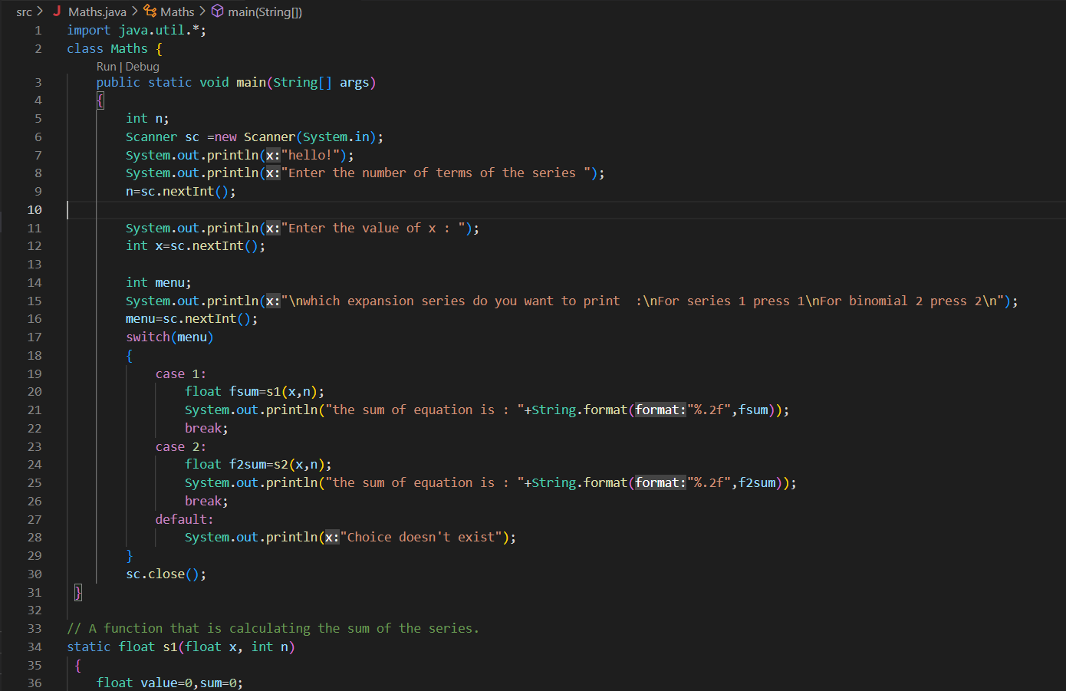

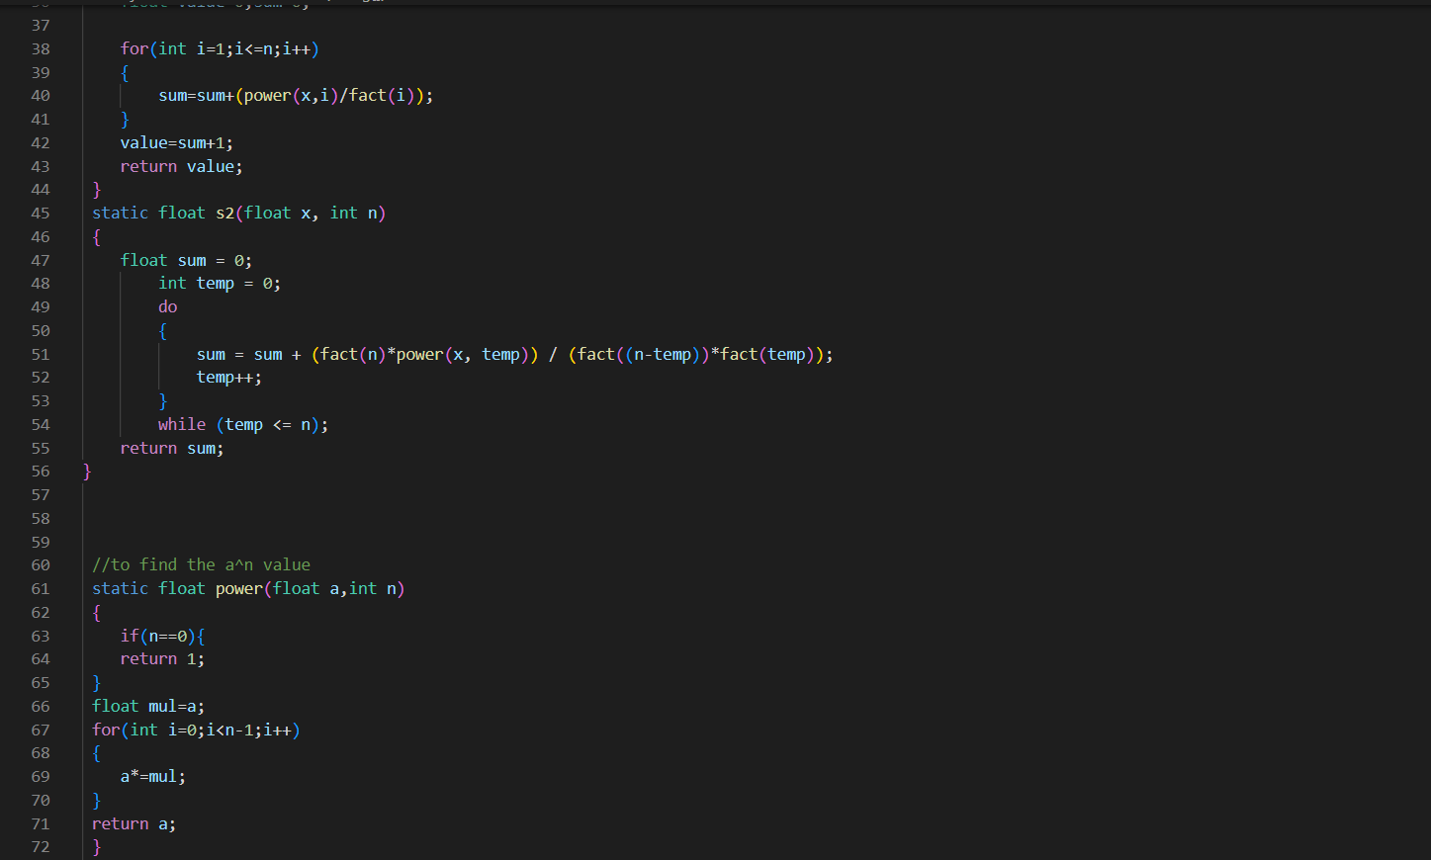

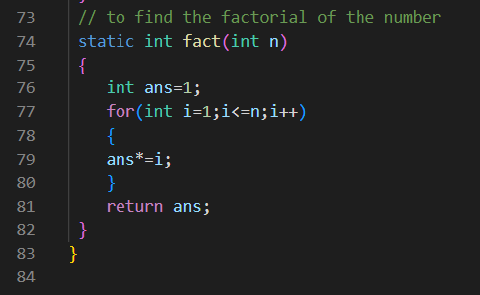

**Output:**

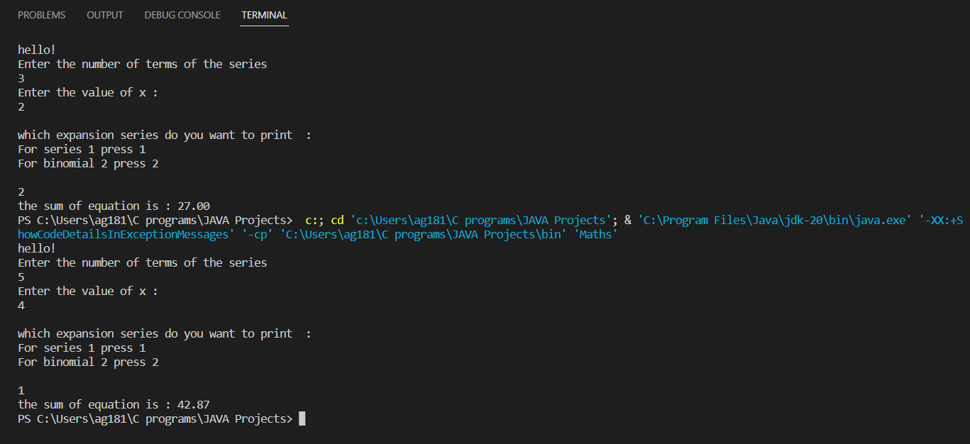

**Conclusion:**

We demonstrated the use of **:** Explore arrays, vectors, classes and objects in C++ and Java. We learnt how to implement objects and how to use them to call functions of another class. Used switch case statement to create a program that allows us to input 2 complex numbers and find out their addition, subtraction, multiplication and division.

**Date: _____________ Signature of faculty in-charge**

**Post Lab Descriptive Questions**

Q.1 Write a program to find the largest of three numbers using the if-else construct.

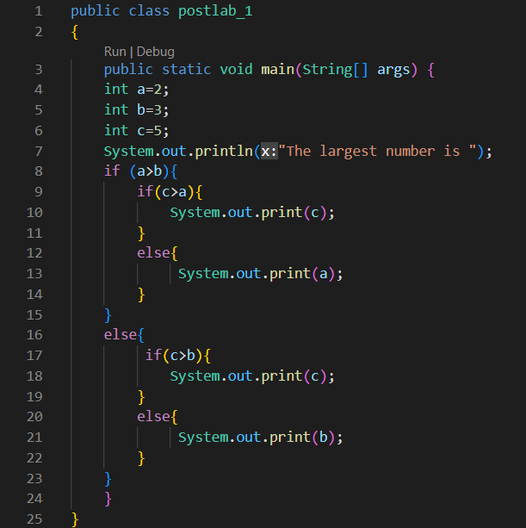

**OUTPUT**



Q.2 Write a program to determine the sum of the following series for a given value of n:

1+½+⅓+....+1/n

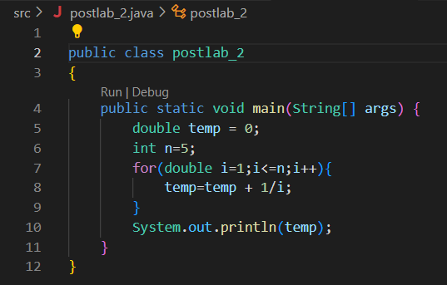

**OUTPUT**

